

**Arab American University/Palestine**

**Faculty of Information Technology**

**Computer System Engineering Department**

**Introduction to data base/ Course**

**Final project _ Medical Center**

**Aamal M. Kmail 201811052**

**Dima N. Abu Jaber 201810543**

**Abeer B. Hanaysheh 201810666**

**Ansam Z. Jawabreh 201811035**

**Dr. Osama Salameh**

Table of Contents

Introduction: 3

Work flow: - 3

Questions: 3

Requirements: 5

Relationships: 6

ER diagram: 7

Mapping: 8

Sql command line : 9

Tables: 14

Conclusion: 17

# Introduction:

A medical center is a facility that deals with some medical conditions if the case in question does not require a hospital. The following database is used for holding data for a local medical center, it contains a specific microscope that we got from collecting data about medical centers in general.

# Work flow: -

The process starts when the patient goes to reception, the receptionist creates a record for the patient, the record initially has the date and it's now accessible for the doctor.

The patient goes a doctor for treatment, the doctor may ask the patient for some tests to understand the problem with the patient, and he may write a prescription for the patient.

The patient has the option to buy the medicine from the medical Center or from somewhere else.

In the last step the patient goes back for reception to pay for his tests that he needed for his treatment.

# Questions:

1. Give the name of employee who work in a specific department

🡪select fname,lname from employeem where dept_id=1;

1. Give existing information about specific employee

🡪select *from employeem where ssn='123456789';

1. Give information about a manager of a specific department

🡪 select *from employeem e join department_m d on(e.ssn=d.manager_ssn) where e.dept_id =1;

1. Count the number of employees in each department

🡪 select dept_id, count(ssn)"number of employees" from employeem group by dept_id;

1. Determine the type of job of each employee

🡪select fname,lname,job_type from employeem join jobs using(job_id);

1. Give existing information about specific patient

🡪select * from patients where pid='123456';

1. Determine information of medicine for each patient

🡪 select p.pid, fname, lname, name ,code from patients p join take_medicine t on(p.pid=t.pid) join medicines m on(t.code=m.code);

1. Count the number of patients who take a medicine in a certain date

🡪select count(pid)"number of patients",date_medicine from take_medicine group by date_medicine;

1. Count the number of patients who take the same medicine

🡪select count(pid)"number of patients",name"name of medicine" from take_medicine join medicines using(code) group by name;

1. Give the name of tests for a certain patient

🡪 select fname ,lname ,test_name ,price,date_test from patients p join have_test t on(p.pid=t.p_id) join test b on(t.test_id=b.test_id) where p.pid='123456';

1. Give the name of the doctor who treats the patient

🡪 select e.fname"Doctor fname",e.lname"Doctor lname",e.ssn,p.fname"patient fname",p.lname"patient lname",p.pid from employeem e join treats t on(e.ssn=t.doctor_id) join patients p on(p.pid=t.patient_id);

1. Give the treatment cost (test cost) that paid from patient

🡪select p.fname,p.lname,sum(b.price)"cost of tests" from test b join have_test t on(b.test_id=t.test_id) join patients p on(p.pid=t.p_id) group by p.fname,p.lname;

1. Give the date in which that the patient record in the center

🡪select p.fname,p.lname,r.date_r from patients p join record r on(p.pid=r.patient_id);

1. Give the name of employee who records the patient

🡪 select e.fname"receptionist fname", e.lname"receptionist lname",p.lname"patient" from employeem e join record r on(e.ssn=r.emp_id) join patients p on(p.pid=r.patient_id);

1. Give the name of employee who do a test for a patient

🡪select e.fname"labEmp fname",e.lname"labEmp lname",p.fname"patient fname",p.lname"patient lname" from employeem e join have_test t on(e.ssn=t.doctor_id) join patients p on(p.pid=t.p_id);

1. Give information about medicine in our center

🡪select *from medicines;

1. Give information about tests

🡪 select * from test;

1. Give information about departments in our center

🡪select*from department_m;

1. Give information about jobs offered by center

🡪 select * from jobs;

1. Give the number of patients in each date

🡪 select count(patient_id)"number of patients",date_r"record date" from record group by date_r;

# Requirements:

1_ medical center is organized into DEPARTMENTS each department has a name , unique number and an employee who manages the department .

2_ The database will store each EMPLOYEES unique social security number , address , name , Gender , phone number , job type , start date , and salary .

3_ Each employee works for one department and the department will have many employees only one of them will be the manager for the department .

4_ Each employee works as a worker in a JOB each job has unique number and title .

5_ The center will receive a PATIENT , each patient has a unique number , gender , phone , name and address .

6_ Each patient take MEDICINE on a certain date in specified countity, each midicnine has unique code , name and price .

7_ Each patient has a record , this record is Attendet by an employee .

8_ If the doctor recommends the patient to do a specific test at a certain date in a centers LAB , each test contains unique number , name and price for this test .

# Relationships:

-> Employees (1-1) Departments as (Manage)

-> Employees (M-1) Departments as (Work_for)

-> Employees (M-1) jobs as (Work_as)

-> Employees (M-1) Records as (Attends)

-> Patients (1-1) Records as (Has)

-> Patients (M-N)Medicines as (Take_Medicine)

-> Employees(M-N) Patients (M-N) test as (Take_test)

-> Employees(N-M)Patients (treates)

# ER diagram:

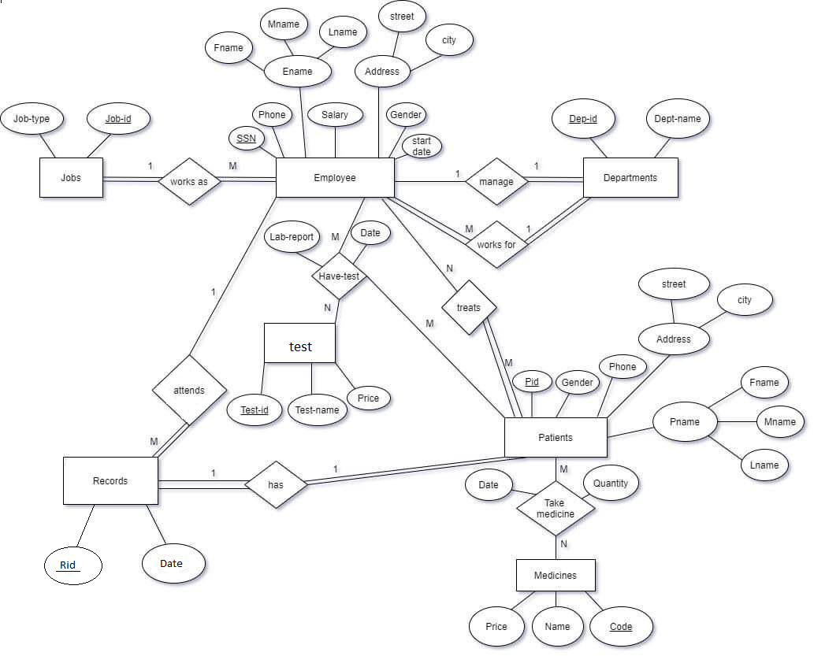

# Mapping

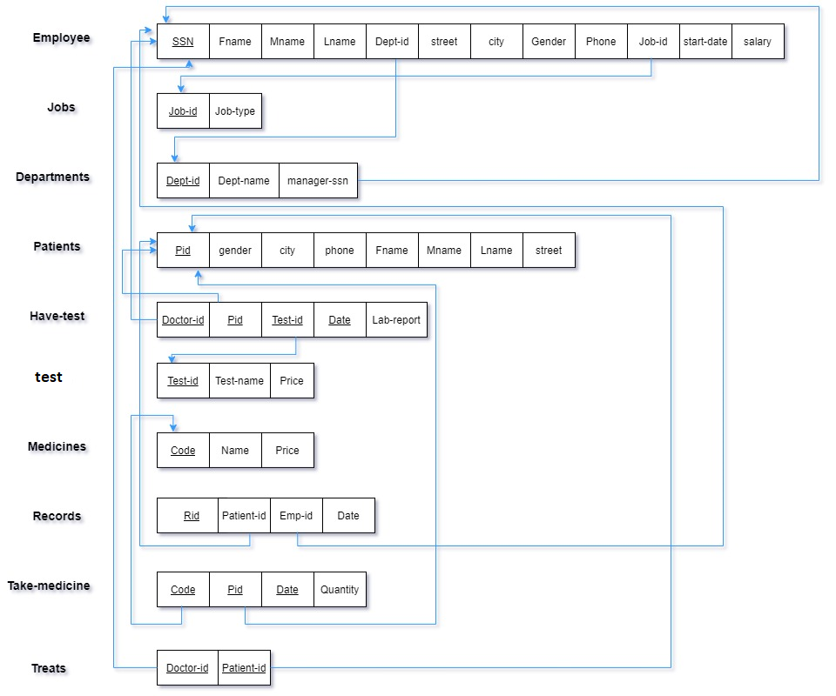

# Sql command line :

create table EmployeeM(

ssn char(9) primary key ,

fname varchar(20) not null,

mname char ,

lname varchar(20) not null,

street varchar(10) ,

city varchar(10) ,

gender char not null,

phone_number char(10) not null,

start_date date not null,

salary decimal(10,2) ,

dept_id int ,

job_id char(4));

create table jobs(

job_id char(4) primary key,

job_type varchar2(20));

create table department_m(

dept_id int primary key,

dept_name varchar2(20) not null,

manager_ssn char(9));

create table patients (

pid char(6) primary key,

gender char not null,

phone char(10),

fname varchar2(20) not null,

mname char,

lname varchar2(30),

street varchar(10),

city varchar2(10));

create table Have_test(

doctor_id char(9) ,

p_id char(6),

test_id char(3),

date_test date ,

lab_report varchar(10),

primary key(doctor_id,p_id,test_id,date_test));

create table test(

test_id char(3),

test_name varchar(20) not null,

price number,

primary key(test_id));

create table medicines(

code char(4) primary key,

name varchar2(20),

price number);

create table record (

Rid number(10) primary key,

patient_id char(6),

emp_id char(9),

date_r date);

create table take_medicine(

code char(4),

pid char(6),

date_medicine date,

quantity number not null,

primary key(code,pid,date_medicine));

create table treats(

doctor_id char(9),

patient_id char(6),

primary key(doctor_id,patient_id));

alter table EmployeeM add constraint e_job foreign key (job_id) references jobs (job_id)on delete set null;

alter table EmployeeM add constraint e_dept foreign key (dept_id) references department_m (dept_id)on delete set null;

alter table department_m add constraint dept_emp foreign key (manager_ssn) references EmployeeM (ssn)on delete set null;

alter table Have_test add constraint t_pat foreign key (p_id) references patients (pid)on delete set null;

alter table Have_test add constraint t_emp foreign key (doctor_id) references EmployeeM (ssn)on delete set null;

alter table Have_test add constraint t_lab foreign key (test_id) references test (test_id)on delete set null;

alter table record add constraint re_pati foreign key (patient_id) references patients (pid)on delete set null;

alter table record add constraint re_emp foreign key (emp_id) references EmployeeM (ssn)on delete set null;

alter table take_medicine add constraint take_m foreign key (code) references medicines (code)on delete set null;

alter table take_medicine add constraint take_p foreign key (pid) references patients (pid)on delete set null;

alter table treats add constraint trea_emp foreign key (doctor_id) references EmployeeM (ssn)on delete set null;

alter table treats add constraint trea_pati foreign key (patient_id) references patients (pid)on delete set null;

insert into jobs values('1234','doctor');

insert into jobs values('3426','nurse');

insert into jobs values('2314','receptionist');

insert into EmployeeM values ('123456789','ahmad','a','saleh','st1235','jenin', 'm','0123456789','12-dec-20',10000.25,null,'1234');

insert into department_m values('1','doctors','123456789');

insert into EmployeeM values ('987654321','mohamad','s','salem','st1455','ramallah','m','0569504778','12-nov-20',5000.87,1,'1234');

insert into department_m values('2','dental_section','123456789');

insert into department_m values('3','nursing_section','987654321');

insert into EmployeeM values ('123987456','salma','y','khalil','st475','jarusallem','f','0569754778','22-nov-20',80000.87,3,'3426');

insert into EmployeeM values ('654327865','farah','j','ahmad','st473','hebron','f','0566543778','16-dec-20',50000.87,1,'2314');

insert into patients values('123456','F','0987654321','sally','M','rami','str611','jenin');

insert into patients values('123564','M','0934254321','sameer','A','kareem','str631','tubas');

insert into patients values('763564','M','0934257491','tamer','E','jad','str541','jenin');

insert into patients values('123459','F','0987654321','istabraq ','M','rami','str619','jenin');

insert into patients values('123457','F','0987654333','jolly ','M','rom','str622','jenin');

insert into Have_test values('123456789','123456','123','12-jan-21','done');

insert into Have_test values('123456789','123564','124','13-jan-21','done');

insert into Have_test values('123456789','763564','156','6-feb-21','done');

insert into test values('123','RBC',500);

insert into test values('124','LDL',600);

insert into test values('156','BLT',400);

insert into medicines values('1234','relaxon',50);

insert into medicines values('1235','scobutyl',40);

insert into medicines values('1236','paracetamol',10);

insert into record values(1,'123456','654327865','12-jan-21');

insert into record values(2,'123564','654327865','13-jan-21');

insert into record values(3,'763564','654327865','6-feb-21');

insert into take_medicine values('1234','123456','12-jan-21',2);

insert into take_medicine values('1236','123457','12-jan-21',5);

insert into take_medicine values('1235','763564','6-feb-21',3);

insert into take_medicine values('1236','123564','13-jan-21',5);

insert into take_medicine values('1236','123459','13-jan-21',5);

insert into treats values('123456789','123564');

insert into treats values('123456789','763564');

insert into treats values('123456789','123456');

update employeem set dept_id=1 where ssn='123456789';

alter table employeem modify(dept_id not null);

alter table department_m modify(manager_ssn not null);

alter table employeem modify(job_id not null);

alter table record modify(patient_id not null);

alter table record modify(emp_id not null);

# Tables:

**Have_test:**

|  |  |  |  |  |
| --- | --- | --- | --- | --- |
| **Lap_report** | **Data_test** | **Test_id** | **P_id** | **Doctor_id** |
| done | 12-jan-21 | 123 | 123456 | 123456789 |
| done | 13-jan-21 | 124 | 123564 | 123456789 |
| done | 6-feb-21 | 156 | 763564 | 123456789 |

**Medicines:**

|  |  |  |
| --- | --- | --- |
| **price** | **name** | **code** |
| 50 | relaxon | 1234 |
| 40 | scobutyl | 1235 |
| 10 | paracetamol | 1236 |

**Record:**

|  |  |  |  |
| --- | --- | --- | --- |
| **Date_r** | **Emp_id** | **patient_id** | **Rid** |
| 12-jan-21 | 654327865 | 123456 | 1 |
| 13-jan-21 | 654327865 | 123564 | 2 |
| 6-feb-21 | 654327865 | 763564 | 3 |

**Patients:**

|  |  |  |  |  |  |  |  |
| --- | --- | --- | --- | --- | --- | --- | --- |
| **Pid** | **gender** | **phone** | **fname** | **mname** | **lname** | **street** | **city** |
| 123456 | F | 0987654321 | sally | M | rami | Str611 | Jenin |
| 123564 | M | 0934254321 | sameer | A | kareem | Str631 | Tubas |
| 763564 | M | 0934257491 | tamer | E | jad | Str541 | Jenin |
| 123459 | F | 0987654321 | istapraq | M | rami | Str619 | Jenin |
| 123457 | F | 0987654333 | jolly | M | rom | Str622 | Jenin |

**Take_medicine:**

|  |  |  |  |
| --- | --- | --- | --- |
| **code** | **pid** | **date_medicine** | **quantity** |
| 1234 | 123456 | 12-jan-21 | 2 |
| 1236 | 123457 | 12-jan-21 | 5 |
| 1235 | 763564 | 6-feb-21 | 3 |
| 1236 | 123564 | 13-jan-21 | 5 |
| 1236 | 123459 | 13-jan-21 | 5 |

**Department_m:**

|  |  |  |
| --- | --- | --- |
| **Managers** | **Dept_name** | **Dept_id** |
| 123456789 | Doctors | 1 |
| 123456789 | Dental_section | 2 |
| 987654321 | Nursing_section | 3 |

**Jobs:**

|  |  |
| --- | --- |
| **Job_type** | **JOB_ID** |
| Doctor | 1234 |
| nurse | 3426 |
| receptionst | 2314 |

**Test:**

|  |  |  |
| --- | --- | --- |
| **Price** | **Test_name** | **Test_id** |
| 500 | RBC | 123 |
| 600 | LDL | 124 |
| 400 | BLT | 156 |

**Treats:**

|  |  |
| --- | --- |
| **PATIEN_ID** | **DOCTOR_ID** |
| 123456 | 123456789 |
| 123564 | 123456789 |
| 763564 | 123456789 |

**Employeem:**

|  |  |  |  |  |  |  |  |  |  |  |  |
| --- | --- | --- | --- | --- | --- | --- | --- | --- | --- | --- | --- |
| **JOB_ID** | **DEPT_ID** | **SALARY** | **START_DATE** | **PHONE_NUMBER** | **GENDER** | **CITY** | **STREET** | **LNAME** | **MNAME** | **FNAME** | **SSN** |
| 1234 | null | 1000.25 | 12-dec-20 | 0123456789 | M | jenin | St1235 | Saleh | A | Ahmad | 123456789 |
| 1234 | 1 | 5000.87 | 12-nov-20 | 0569504778 | M | ramallah | St1455 | Salem | S | Mohamad | 987654321 |
| 3426 | 3 | 8000.87 | 22-nov-20 | 0569754778 | F | Jerusallem | St475 | Khalil | Y | salma | 123987456 |
| 2314 | 1 | 5000.87 | 16-dec-20 | 0566543778 | F | Hebron | St473 | Ahmad | j | Farah | 654327865 |

# Conclusion:

This project was a practical application of what we learned in data base course and lab, so we created a data base for a medical center and we have schedule the data for each element in this center.

in order to facilitate the process of obtaining information in a short time and with little effort and as easy for us to modify Pre-existing information when something new occurs.

So we can see that data base achieved the following:

Reduced data redundancy

Reduced updating errors and increased consistency

Greater data integrity and independence from applications programs

Improved data access to users through use of host and query languages

Improved data security

Reduced data entry, storage, and retrieval costs

Facilitated development of new applications program